# HOW TO CHOOSE A DUVET

Make your bed even more tempting with our super-comfy  
duvets and pillows. Snuggle up in fine quality - whether  
you go for luxurious down feathers or a machine-  
washable option, we have you covered. The perfect duvet  
can make all the difference to getting a great night's sleep.  
Use our handy guide to help you choose the right one for you

## FIND THE RIGHT DUVET FOR YOU

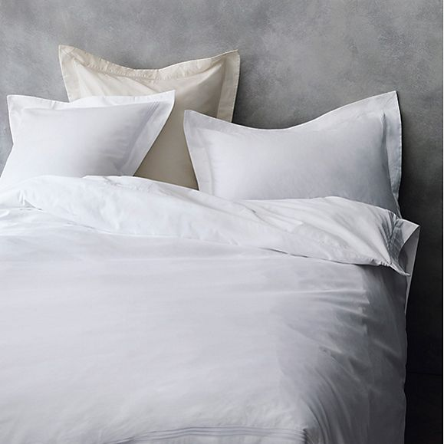

## How to choose your duvet?

There are two important elements to consider when buying a new duvet – the filling and the tog rating. Decide between natural or synthetic fillings and check the tog rating to measure the warmth and thickness of the duvet.

## DUVET FILLINGS

## Natural

Duvets with natural fillings are soft, cosy and comfortable. Draping beautifully around the body for warmth, they make for a breathable and luxurious bedding choice.

[Shop all natural duvets](http://www.marksandspencer.com/l/home-and-furniture/duvets-and-pillows/?facetOpen=true&cachedFilters=FID_20097077+FID_4294953553+FID_4294960962+FID_4294955731+FID_4294953554+24+0+375+0+375&priceMin=0&priceMax=375&currentPriceMin=0&currentPriceMax=375&lastSelectedSize=&resultsPerPage=24&sortBy=product_is_new|1&pageChoice=1&selectedAccordions=checkbox-2000|checkbox-10|checkbox-36|checkbox-456|checkbox-449)

[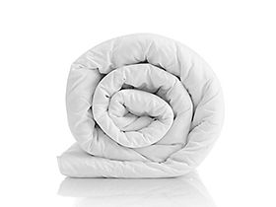](http://www.marksandspencer.com/l/home-and-furniture/duvets-and-pillows/duvets-n-byr05/?facetOpen=true&cachedFilters=FID_20097077+FID_4294953553+24+0+350+0+350&priceMin=0&priceMax=350&currentPriceMin=0&currentPriceMax=350&lastSelectedSize=&resultsPerPage=24&sortBy=product_is_new|1&pageChoice=1&selectedAccordions=checkbox-2000|checkbox-10|checkbox-36|checkbox-456|checkbox-449)

#### Duck feather & down

Made from 85% new duck feather and 15% new duck down, it’s perfect for those who prefer a heavier duvet

[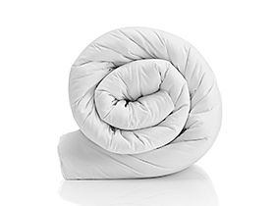](http://www.marksandspencer.com/l/home-and-furniture/duvets-and-pillows/duvets-n-byr05/?facetOpen=true&cachedFilters=FID_20097077+FID_4294953553+24+0+350+0+350&priceMin=0&priceMax=350&currentPriceMin=0&currentPriceMax=350&lastSelectedSize=&resultsPerPage=24&sortBy=product_is_new|1&pageChoice=1&selectedAccordions=checkbox-2000|checkbox-10|checkbox-36|checkbox-456|checkbox-449)

#### Luxury White Duck Down

With a high down content for a luxuriously light, airy feel and wonderful drape. Soft, cosy and breathable.

[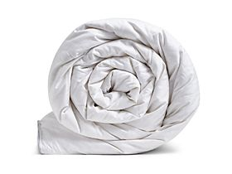](http://www.marksandspencer.com/l/home-and-furniture/duvets-and-pillows/duvets-n-byr05/?facetOpen=true&cachedFilters=FID_20097077+FID_4294954966+24+0+350+0+350&priceMin=0&priceMax=350&currentPriceMin=0&currentPriceMax=350&lastSelectedSize=&resultsPerPage=24&sortBy=product_is_new|1&pageChoice=1&selectedAccordions=checkbox-2000|checkbox-10|checkbox-36|checkbox-456|checkbox-449)

#### Luxury Hungarian Goose Down

Naturally insulating and breathable, with large clusters of wonderfully soft goose down in a 300 thread count pure cotton cover

[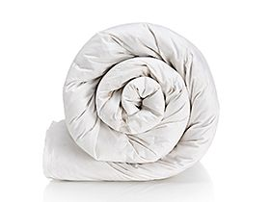](http://www.marksandspencer.com/l/home-and-furniture/duvets-and-pillows/duvets-n-byr05/?facetOpen=true&cachedFilters=FID_20097077+FID_4294953554+FID_4294917547+24+0+350+0+350&priceMin=0&priceMax=350&currentPriceMin=0&currentPriceMax=350&lastSelectedSize=&resultsPerPage=24&sortBy=product_is_new|1&pageChoice=1&selectedAccordions=checkbox-2000|checkbox-10|checkbox-36|checkbox-456|checkbox-449)

#### Silver Pyrenean goose down

Exceptional softness and insulating properties make a wonderfully warm yet light filling.

## Synthetic

Our duvets with synthetic fillings are perfect for anyone looking for a non-allergenic option. They're also machine-washable and easy to care for.

[Shop all synthetic duvets](http://www.marksandspencer.com/l/home-and-furniture/duvets-and-pillows/?facetOpen=true&cachedFilters=FID_20097077+FID_4294953553+FID_4294960962+FID_4294955731+FID_4294953554+24+0+375+0+375&priceMin=0&priceMax=375&currentPriceMin=0&currentPriceMax=375&lastSelectedSize=&resultsPerPage=24&sortBy=product_is_new|1&pageChoice=1&selectedAccordions=checkbox-2000|checkbox-10|checkbox-36|checkbox-456|checkbox-449)

[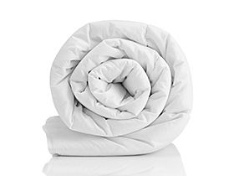](http://www.marksandspencer.com/l/home-and-furniture/duvets-and-pillows/duvets-n-byr05/?facetOpen=true&cachedFilters=FID_20097077+FID_4294961180+24+0+350+0+350&priceMin=0&priceMax=350&currentPriceMin=0&currentPriceMax=350&lastSelectedSize=&resultsPerPage=24&sortBy=product_is_new|1&pageChoice=1&selectedAccordions=checkbox-2000|checkbox-10|checkbox-36|checkbox-456|checkbox-449)

#### Supremely washable

Breathable Dacron filling, washable and non-allergenic duvet, a great all-round choice for those who wash their duvets frequently.

[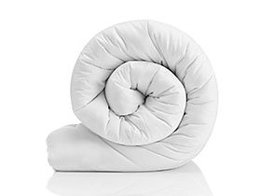](http://www.marksandspencer.com/l/home-and-furniture/duvets-and-pillows/duvets-n-byr05/?facetOpen=true&cachedFilters=FID_20097077+FID_4294961180+24+0+350+0+350&priceMin=0&priceMax=350&currentPriceMin=0&currentPriceMax=350&lastSelectedSize=&resultsPerPage=24&sortBy=product_is_new|1&pageChoice=1&selectedAccordions=checkbox-2000|checkbox-10|checkbox-36|checkbox-456|checkbox-449)

#### Anti-allergy

A washable and skin-friendly option for those with sensitivities, this duvet has been endorsed by the British Allergy Foundation

[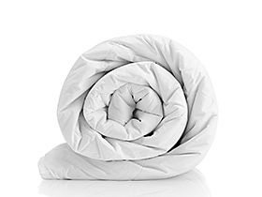](http://www.marksandspencer.com/l/home-and-furniture/duvets-and-pillows/duvets-n-byr05/?facetOpen=true&cachedFilters=FID_20097077+FID_4294961180+24+0+350+0+350&priceMin=0&priceMax=350&currentPriceMin=0&currentPriceMax=350&lastSelectedSize=&resultsPerPage=24&sortBy=product_is_new|1&pageChoice=1&selectedAccordions=checkbox-2000|checkbox-10|checkbox-36|checkbox-456|checkbox-449)

#### So Soft

This luxuriously soft duvet has individual pockets for even warmth and cosiness. Enjoy the feel of down with the ease of a washable filling

[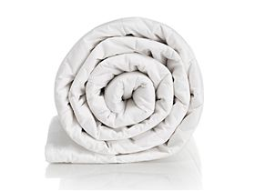](http://www.marksandspencer.com/l/home-and-furniture/duvets-and-pillows/duvets-n-byr05/?facetOpen=true&cachedFilters=FID_20097077+FID_4294961180+FID_4294928189+24+0+350+0+350&priceMin=0&priceMax=350&currentPriceMin=0&currentPriceMax=350&lastSelectedSize=&resultsPerPage=24&sortBy=product_is_new|1&pageChoice=1&selectedAccordions=checkbox-2000|checkbox-10|checkbox-36|checkbox-456|checkbox-449)

#### Comfortably Cool

With a pure cotton cover and clever keep-cool filling, this is perfect for warm nights.

## WHAT TOG?

## Choosing a Tog Rating

A tog rating is a measure of the duvet’s ability to trap warm air. The higher the rating, the warmer the duvet will be. Choosing the right tog is important because if you’re too hot or too cold in bed, you won’t get a good night’s sleep. Use the chart below as a guide.

[](http://www.marksandspencer.com/l/home-and-furniture/duvets-and-pillows/duvets)

## Tog Ratings explained

The weight, softness and warmth of a duvet depends on its tog rating and filling. The higher the tog rating, the warmer the duvet

### 4.5 Tog

A lighter duvet, perfect for using during summer months or in warmer climates

[Shop now](http://www.marksandspencer.com/l/home-and-furniture/duvets-and-pillows/45-tog-n-1z13uz7)

### 7.5 Tog

A lighter duvet, perfect for using during summer months or in warmer climates

[Shop now](http://www.marksandspencer.com/l/home-and-furniture/duvets-and-pillows/75-tog-n-1z12wm8)

### 10.5 Tog

Ideal for spring and autumn, or for using year-round in a home with central heating

[Shop now](http://www.marksandspencer.com/l/home-and-furniture/duvets-and-pillows/105-tog-n-1z13uz4)

### 13.5 Tog

Suitable for cooler months or if you prefer a really warm and snug duvet (or if your bedroom is cold)

[Shop now](http://www.marksandspencer.com/l/home-and-furniture/duvets-and-pillows/135-tog-n-1z13uz3)